

Report to Manhattan Community Board 1 – Battery Park City Committee
September 3, 2026
Presented by Nick Sbordone, BPCA
(646) 531-2276 | nicholas.sbordone@bpca.ny.gov
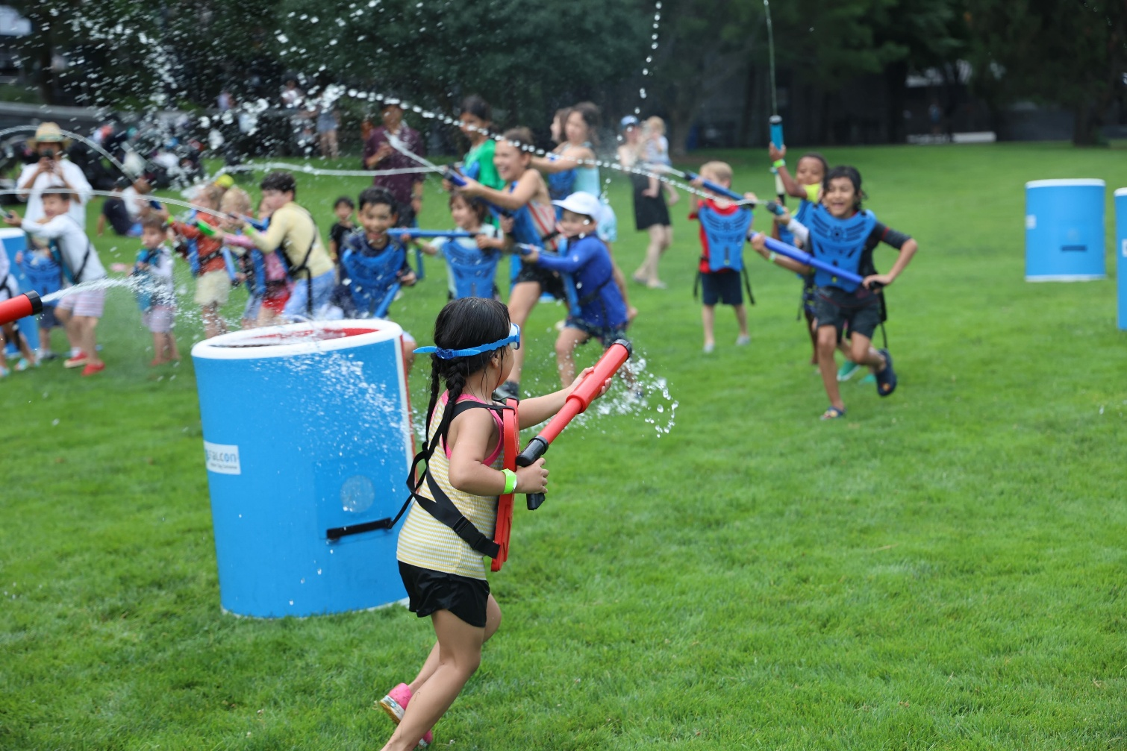

ONCE MORE UNTO THE BREACH: Wet & fearless participants enjoy our Water Tag Extreme event in Rockefeller Park on August 7.
NEIGHBORHOOD & PROJECT UPDATES:

- North / West Battery Park City Resiliency Project
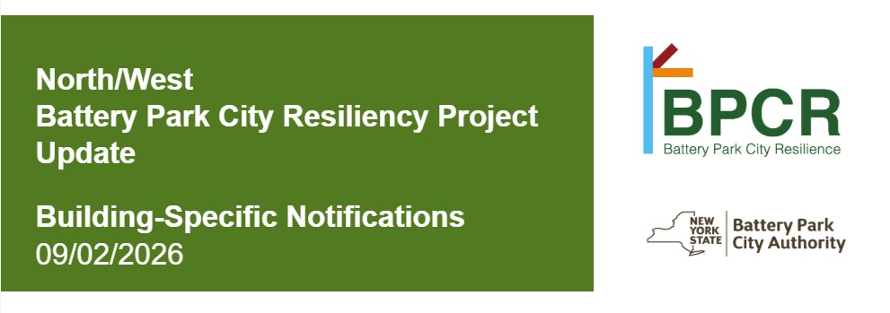

  - Building Specific Email Notifications
    - BPCA is rolling out building-specific email notifications to communicate important construction updates to Battery Park City residents.
    - These notifications will be reserved for construction activities such as overnight work, planned utility shutdowns, or weekend construction that may impact your building. (Routine project updates will continue to be communicated through existing channels, such as the biweekly project newsletter and project website.)
    - Click here to subscribe.

  - COMING UP: South Esplanade Mobilization – Starting next week (w/o September 7, 2026) mobilization for South Esplanade (Reach 6A North/6A South) will begin.

What to expect–
    - Light fencing and construction barriers will be installed starting the week of September 7.
    - Crews will be onsite conducting flood barrier system construction work in this area through 2030.
    - Ongoing excavation, jackhammering, and other construction activities
Getting around–
- South Esplanade Pedestrian Access is restricted
- OPEN: Rector Park East / West, West Thames Park, Wagner Park (as well as – in North BPC – BPC Ball Fields, Rockefeller Park, and Teardrop Park North & South)
- CLOSED: South Esplanade access north of Albany Street
- BPC Resiliency “Drop-Ins”:
    - Tuesdays, September 1–December 22, 5-6PM @ 200 Rector Place Community Room
    - Fridays, September 18–December 18, 12-1PM @ 6 River Terrace

- Sign up for our biweekly construction newsletters. Recent issues include:
- NWBPCR Newsletter – August 25, 2026
- NWBPCR Newsletter – August 11, 2026
- NWBPCR Newsletter – July 28, 2026

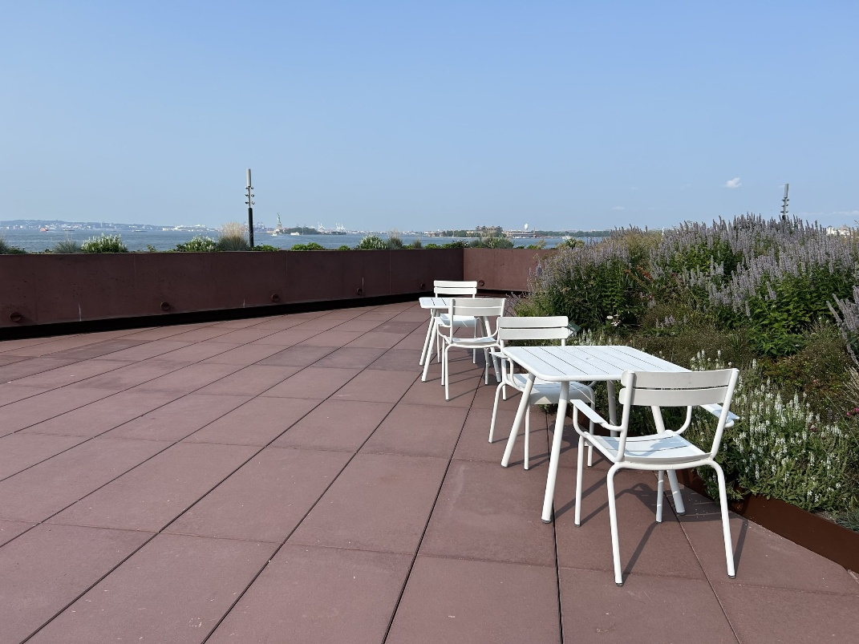
- South Battery Park City Resiliency Project – Wagner Park Pavilion Rooftop Seating
  - BPCA has added tables and seating to the Wagner Park Pavilion Rooftop for visitors to enjoy when using the park.
  - Tables and chairs to be taken in for inclement weather, special events, and prior to / following the pavilion’s daily operating hours of 7:30AM-9PM (8AM-6:30PM from November 1-April 31).
  - For more information on the Wagner Pavilion classroom or to reserve the space, click here or email wagnerclassroom@bpca.ny.gov.
  - Read more about the new Wagner Park here.

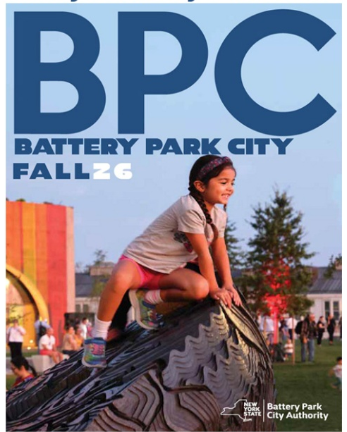
- HOT OFF THE PRESS: BPC’s Fall 2026 Program & Event Guide
- Fall’s a ball in BPC! Battery Park City’s all-free public events this season feature a robust lineup across the neighborhood from September through December, including performances, major festivals and celebrations such as Illumination Light Art Festival, art, film series, fitness, and more.
- Battery Park City will also host a full week of environmental events to celebrate Climate Week, reflecting the neighborhood’s legacy of responsibly stewarding environmental leadership and education.
- Highlights this month include:

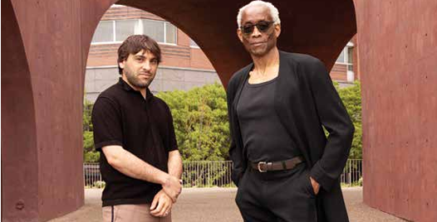
  - Bill T. Jones: World Premiere – Thursday, September 10; Saturday, September 12; and Sunday, September 13 @ 7:30PM, Wagner Park. The world premiere of Curriculum IV: Spin and Spin! Turn! Turn! Turn! by visionary artist Bill T. Jones responds to a performance altered by the events of September 11, 2001. Commemorating the 25th Anniversary, this new work brings dance back to Lower Manhattan, influenced by resilience and the passage of time

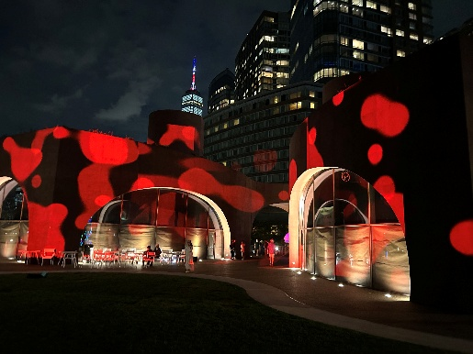
  - Illumination Light Art Festival – Thursday, September 17-Saturday, September 19, 7PM @ Wagner Park. Step into Illumination.nyc, an immersive outdoor light festival where interactive art, dazzling installations, and live DJs transform the night. Explore, play, and dance under the stars in a luminous, one-of-a-kind experience.


  - Son Rope Pera – Thursday, September 26, 6PM @ Wagner Park. Son Rope Pera is a Mexican fusion band based in Naucalpan, a suburb of Mexico City. Primarily playing cumbia, they integrate the use of Mexican marimba music that is traditional in the folklore of their country and such other genres as danzón, rock, ska and others.

  - Climate Week In BPC: Highlights include a symposium with University of Miami’s Climate Resilience Institute on Nature-Based Infrastructure for Coastal Resilience, a lecture on spittlebugs, fishing, beekeeping and more.
    - CLIMATE RESILIENCE INSTITUTE – Tuesday, September 22, 9AM-5PM @ Wagner Park Pavilion Classroom
    - SPITTLEBUGS AND CLIMATE CHANGE – Tuesday, September 22, 3PM @ 6 River Terrace
    - MEET THE BEEKEEPER – Wednesday, September 23, 1:30PM @ Rockefeller Park
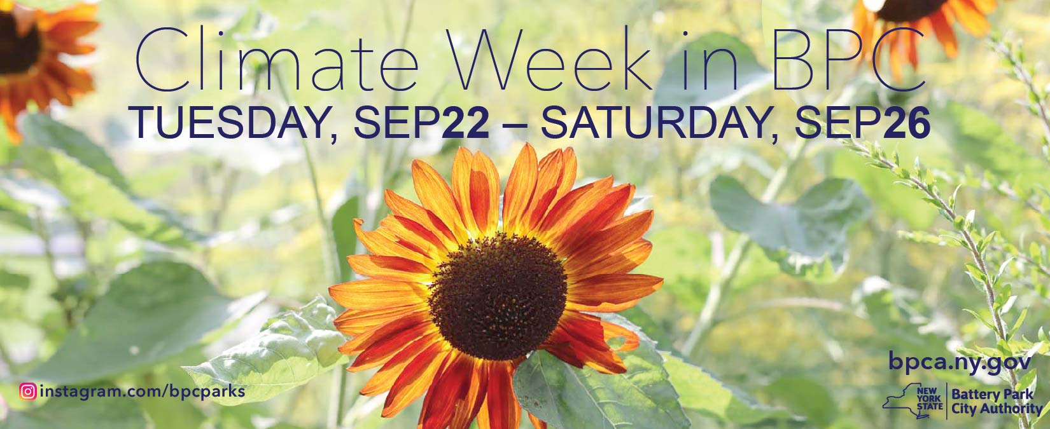
    - FUN, FEMME FISHING – Wednesday, September 23, 6PM @ Wagner Park Tide Deck
    - ARTIST TALK & PANEL: 100 PRACTICES FOR A CHANGING LANDSCAPE – Wednesday, September 23, 6:30PM @ Wagner Park Pavilion Classroom
    - PREPARING FOR THE FUTURE – AT THE WATER’S EDGE:
RESILIENCY FOR LOWER MANHATTAN – Friday, September 25, 8:30-11:30AM @ Wagner Park Pavilion Classroom
    - FOREST BATHING FOR CLIMATE – Friday, September 25, 5PM @ Teardrop Park
    - SKYSCRAPER EQUINOX WITH THE SKYSCRAPER MUSEUM – Saturday, September 26, 10:30AM @ Skyscraper Museum (39 Battery Place)

- COMMUNITY REMINDER: Dogs on Lawns / in BPC
  - While leashed pets are permitted on hard surfaces throughout Battery Park City, they are not permitted on parks lawns or art installations. Unleashed pets are permitted in BPC’s dog runs only.
  - While summonsing is never the goal, BPC Special Patrol Officers may issue summonses for “Dogs Off Leash” violations.
  - READ MORE: It’s a Dog’s Life in BPC

ANNOUNCEMENTS:

- Join the BPCA Team!
  - BPCA is an Equal Opportunity Employer and values a diverse and dedicated work force. All interested and qualified candidates are encouraged to apply using the “Apply Here” link in the postings on our EMPLOYMENT OPPORTUNITIES page.

- Upcoming Permitted Walks / Runs Events
Organization/Event | Event Type | Event Date(s) & Approx. Time | Attendance | Street Closures? | Notes
Corporate FunRun | Walkathon | Thurs., 9/17  5PM – 9PM | 300 | N/A | LOCATION: Route loops around Rockefeller Park via River Terrace and Esplanade
American Lebanese Syrian Assoc. Charities, Inc. (St Jude’s Children’s Research Hospital) | Walkathon | Sun., 9/20  7AM – 2PM | 700 | N/A | LOCATION: Rockefeller Park.  Setup Day on Sat., 9/19
Stephen Siller Tunnel to Towers 5K | Walkathon | Sat., 9/26 & Sun., 9/27  8AM – 6PM | 20,000 | West Street from Canal to Battery Place | LOCATION: Route not coming through BPC, only West Street. All other components, including neighborhood security protocols, traffic closures, and post-race festival on Vesey Street remain same as prior years.
Associated Handicapped Rehabilitation Services  New York City (AHRC NYC) | Walkathon | Sat., 10/3  7AM – 2PM | 150 | N/A | LOCATION: Rockefeller Park.  Setup Day on Fri., 10/2.
Autism Speaks | Walkathon | Sun., 10/4  7AM – 10AM | 800 | N/A | LOCATION: Pass through loop via South BPC (Battery Place to 2nd Place)

BPCA – Allied Universal Quality of Life Statistics
August 2025 vs. August 2026
TOPIC |  | 2025 | 2026
Graffiti |  | 0 | 1
Homeless |  | 28 | 52
Lost / Found Property |  | 6 | 6
Park Rules |  | 3 | 9
Vendor / Solicitor |  | 1 | 1
Dogs |  | 7 | 39

BPCA – Allied Universal Quality of Life Statistics
July 2025 vs. July 2026

TOPIC |  | 2025 | 2026
Graffiti |  | 1 | 1
Homeless |  | 33 | 48
Lost / Found Property |  | 6 | 3
Park Rules |  | 5 | 3
Vendor / Solicitor |  | 6 | 1
Dogs |  | 5 | 17

200 Liberty Street, 24th Floor, New York, NY 10281, Tel.: (212) 417-2000 | VISIT US AT www.bpca.ny.gov
facebook.com/batteryparkcityparks |  twitter.com/bpca_ny |  instagram.com/bpcparks |  threads.net/@bpcparks

